CS-007 Wet Layup & Vacuum Bagging
Doc ID | CS-007
Title | Wet Layup & Vacuum Bagging
Revision | D
Status | Draft, pending Lead signature
Effective date | 2026-10-10
Supersedes | Verbal wet-layup training

Approvals
Role | Name | Date
Author | Simon Starbuck (drafted with Claude, SN6 Resources) | 2026-07-12
Reviewer | simon (reviewer agent) | 2026-10-10
Approver (Composites Lead)

Revision history
Rev | Date | Author | Description of change
A | 2026-07-12 | Claude | Initial outline
B | 2026-07-28 | Claude | Language pass: fewer em dashes for rhythm variety, no content change.
C | 2026-08-28 | Claude | Out of outline, engineering pass (CS-000 Rev C conventions). §7's ten numbered lines became a procedure with subsections; every number in it was already in Rev B or its references, so nothing was invented, only unpacked. §4 definitions written out. Figure 1 draws the bag stack with the breather clearance rule, the one that turns a bagged part into a bagged part glued to its breather. Photo placeholders stay until the first SN6 wet layup.
D | 2026-10-10 | Claude (doc overhaul, requested by Simon Starbuck) | R1 is now the Gougeon (US) 105/206 TDS the numbers came from, not the UK sheet. West 209 added to scope, materials and mixing (3:1 pumps, 3.68:1 by weight). §6 quotes the West SDSs now on file. New shall in §7.1 step 4 (hardener minimum temperature) and new may in §7.4 step 4 (release film, mylar or caul plate where the WO says). Each ply is checked against the run's stack instead of ticked. App steps named: drop-test readings in the "Wet layup and bag" note, the cure buy-off and hold in §7.6, the Foam wrapped steps in §7.7. Honeycomb cores in scope for the skins. Status drops the photos note: SN6 wet layups have run. The lead-added drop-test should (R-007-04) is withdrawn until the cure hold looks back past a blocker (R-007-13); §7.5 states the app limit as a plain paragraph. Fact-check: §6 adds H302 and H312 from the West SDSs and safety glasses from their §8; team numbers labelled as team rules; the valve reopened after the drop test (new §7.5 step 4), with the gauge on the bag side; the mold record updated at demould (new §7.6 step 4); the buy-off is a sub-list under step 1. Register R-007-01..13 (04 in part).

1. Purpose
Wet layup is our second core process (seat, flat panels, foam-wrapped wing elements). In SN5 the knowledge was verbal plus one Slack SOP; this doc writes it down with the numbers attached.

2. Scope
Hand lamination with West System 105 (with 206, 205 or 209 hardener), vacuum-bagged, on molds (CS-004-prepped), flat plates, and foam cores (foam-wrapped wing elements). Infusion: CS-006.
Honeycomb (Nomex) cores and inserts: the skins follow this standard. Core-specific rules (core prep, insert fit, crush limits for honeycomb) are not written yet; cores are a candidate standard in CS-INDEX.

3. References
Ref | Document | Where
R1 | West 105/206 TDS, Gougeon Brothers (US) (5:1 by volume, 5.36:1 by weight; pot life 20–25 min @72 °F; thin-film cure 10–15 h; minimum 60 °F) | 03 Datasheets/west-system_slow-epoxy-hardener_206_tds.pdf
R2 | West 105/205 TDS, Gougeon Brothers (US) (fast: pot life 9–12 min @72 °F; minimum 40 °F) | 03 Datasheets/WestSystems-105-205-Epoxy-Resin.pdf
R3 | VB160 film, PP180 peel ply, breather | 03 Datasheets/
R4 | CS-002 (stack), CS-004 (mold prep), CS-008 (mixing/exotherm) | this series
R5 | Simon's layup SOP (Slack, 2026-05-30): 105 "big tank, blue label" + 206 "large metal can, red label", 5:1 | Slack record
R6 | West 105/209 TDS, Gougeon Brothers (US) (3:1 by volume, 3.68:1 by weight; pot life 40–50 min @72 °F; thin-film cure 20–24 h; minimum 70 °F) | 03 Datasheets/105-209-Epoxy-Resin-1.pdf
R7 | West System SDSs: 105 resin, 205 fast, 206 slow and 209 extra slow hardeners | 03 Datasheets/WEST-SDS-105-Epoxy-Resin.pdf, 03 Datasheets/WEST-SDS-205-Fast-Hardener.pdf, 03 Datasheets/WEST-SDS-206-Slow-Hardener.pdf, 03 Datasheets/WEST-SDS-209-Extra-Slow-Hardener.pdf

4. Definitions
- Wet-out: cloth fully saturated by resin: uniform sheen, weave still visible. Swimming in resin is past wet-out, not better.
- Breather: lofted bleed cloth between peel ply and bag. It gives air a path to the vacuum port and absorbs excess resin. It is kept clear of part edges it could bond to; resin that wicks into breather at an edge glues it on.
- Bridging: bag film spanning a corner instead of following it. Under vacuum a bridge either punctures or leaves a resin-rich void at the corner. Pleats exist to prevent it.
- 60:40: target cured fiber:resin ratio by weight. The mix factor in §7.2 deliberately overshoots it; squeegee and breather carry the excess out.

5. Equipment & Materials
West 105 + 206 (default), 205 (small parts) or 209 (hot days and large layups; needs the shop at 70 °F / 21 °C or warmer, R6), calibrated pumps (5:1 by volume for 206 and 205, R1, R2; 3:1 by volume for 209, a different pump head, R6) or scale (weight ratios: 5.36:1 for 206, R1; 5.19:1 for 205, R2; 3.68:1 for 209, R6), brushes/rollers/squeegees, peel ply, breather, VB160, tacky tape, vacuum pump + trap + gauge, and a shut-off valve between trap and pump with the gauge on the trap or bag side of it, never on the pump (CS-006 §5).

6. Safety
The West SDSs (R7) classify the hardeners as worse than the resin. 205, 206 and 209 are each harmful if swallowed (H302), cause severe skin burns and eye damage (H314, H318) and may cause an allergic skin reaction (H317); 205 is also harmful in contact with skin (H312); 206 and 209 may also irritate the lungs (H335), 205 and 209 may damage organs through repeated exposure (H373), and 205 is suspected of causing genetic defects (H341). 105 resin irritates skin and eyes (H315, H319) and may cause an allergic skin reaction (H317). Treat 105 and its hardeners as CS-008 §6 says for every resin system.
Team rules: nitrile gloves (sensitizer; same warning as CS-004 §6), safety glasses with side shields whenever resin or hardener is open (R7 §8; CS-008 §6), ventilation, no solvent on skin; exotherm rules per CS-008 (105/205 in a pot gets hot fast). Respirator with A-filter for large overhead/enclosed laminating.

7. Procedure

7.1 Prerequisites
- Stack frozen and printed on the WO (CS-002 §7.2). Mold sealed and released per CS-004 with its quality checks passed, or plate waxed, or foam core shaped and dry-fitted.
- Cloth cut per the WO ply table; total dry fiber mass weighed and recorded on the WO.
- All consumables (peel ply, breather, bag, tacky tape) cut to size before any resin is mixed. Pot life spent hunting scissors is pot life lost.
- Check the shop temperature against the hardener's minimum before mixing: 206 needs 60 °F (16 °C), 205 needs 40 °F (4 °C), 209 needs 70 °F (21 °C) (datasheet minimums, R1, R2, R6). Below it, pick a hardener whose minimum the shop meets, or wait.

7.2 Resin math and mixing
- Mix mass ≈ dry fiber mass × 0.9 (team factor). That is deliberately more than the 60:40 cured target implies: the squeegee and the breather take the excess out, and the cured part lands near 60:40. Record mixed and final masses on the WO to tune this factor.
- Mix per CS-008 discipline. With the calibrated pumps, 5:1 by volume, one FULL stroke of each pump per shot, never partial strokes (R1). By scale: 5.36:1 for 206, 5.19:1 for 205 (CS-008 §5). 209 uses the 3:1 pumps, not the 5:1 pumps: check the pump head before the first stroke. By scale, 209 is 3.68:1 (R6).
- Pot life budget, 206 at 72 °F: 20–25 min per 100 g pot (R1). 205: 9–12 min per 100 g at 72 °F (R2). 209: 40–50 min per 100 g at 72 °F (R6). Bigger jobs mix several small pots rather than one large one; a pot that warms is a pot that is about to gel (CS-008 §6).

7.3 Wet-out
- Wet out ply-by-ply per the WO ply table: resin on, then squeegee each ply until shiny-wet with the weave visible, not swimming. Chase dry (white) patches before the next ply goes on; you will not see them again.
- Check each ply against the run's stack (Stack & BOM) as it goes on. Edit any change, a substitution or an extra ply, into the run's stack and write the reason in that ply's Notes (CS-002 §7.4). A pen tick on a printed traveler is allowed as well.
[ PHOTO: correctly wetted ply: uniform sheen, weave visible, no pooling ]

7.4 Bag
- Peel ply over the full laminate, past its edges.
- Breather over the peel ply, held back from every part edge it could bond to (Figure 1).
- Bag with VB160 and tacky tape, pleats at corners and every 300–400 mm of curved perimeter; CS-006 §7.3 rules apply, including the trap between bag and pump.
- Where the WO says so, you may replace the peel ply with a release film (A4000R) or a mylar sheet, or add a caul plate over the peel ply. These are still under test (2026-09). Write which one you used in the WO and photograph the finished surface.
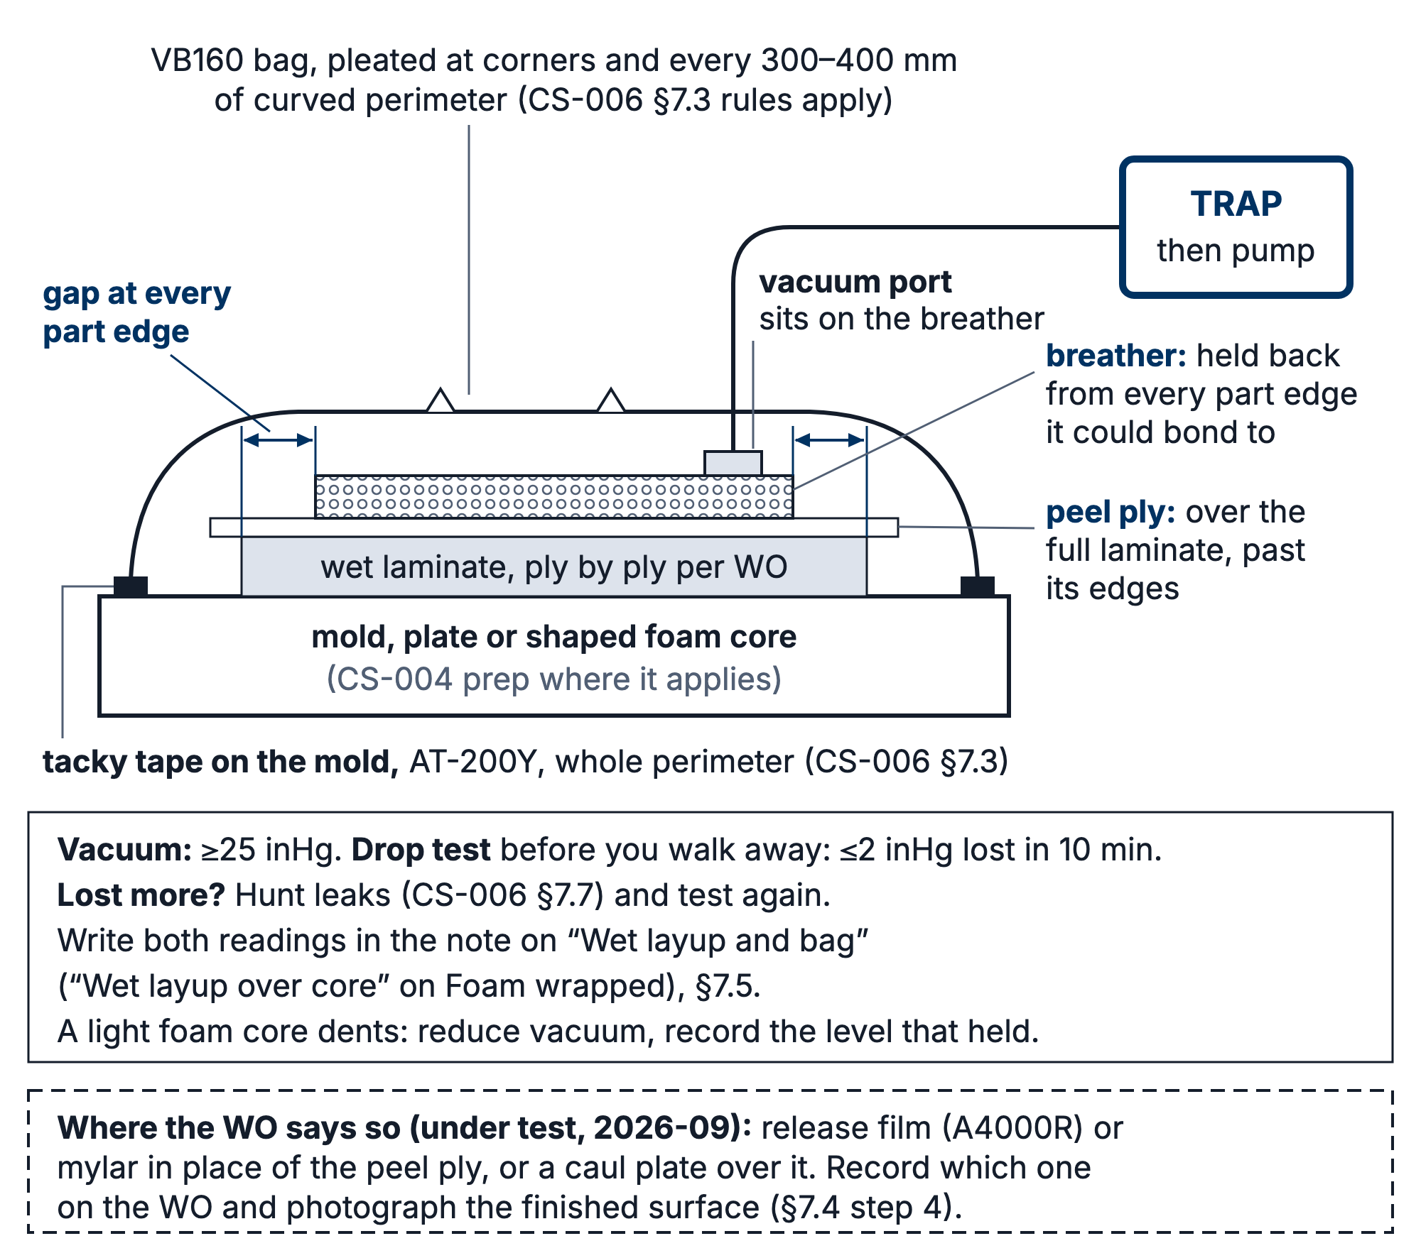
Figure 1. The wet-layup bag in section. The breather covers the peel ply but stops short of every part edge; resin that wicks into breather at an edge bonds it to the part.

7.5 Vacuum and drop test
- Pull to ≥25 inHg (team acceptance criterion).
- Drop test before walking away: isolate the pump; the bag shall lose ≤2 inHg over 10 minutes (team acceptance criterion). The gauge must be on the bag side of the closed valve (CS-006 §5). Write the start and end readings in the note on the "Wet layup and bag" step ("Wet layup over core" on a Foam wrapped run). Leak hunting per CS-006 §7.7.
- On light foam cores, watch for vacuum crush: if the core dents, reduce vacuum and record the level that held on the WO, per part, so the next build starts from a number.
- After the drop test passes, open the valve again and check the gauge climbs back to 25 inHg before you walk away. A valve left shut bleeds the bag down overnight.
The Mold wet lay and Foam wrapped techniques have no drop-test step, so the app does not block on this test. The cure hold reads only the step directly before it, so a drop-test step placed between "Wet layup and bag" and "Cure and demould" (or "Cure") would switch the hold off. Until the app changes, the drop test is recorded in the "Wet layup and bag" note.
[ PHOTO: bagged wet layup under vacuum, pleats visible, gauge in frame ]

7.6 Cure and demold
- Leave bagged under vacuum overnight minimum. 206 reaches thin-film solid in 10–15 h at 72 °F (R1); a cold shop runs longer. Before you leave, record the buy-off:
- Sign "Wet layup and bag" ("Wet layup over core" on a Foam wrapped run); signing needs Wet layup training in the app.
- Under "Resin mixed", pick West 105 + 206 slow, West 105 + 205 fast or West 105 + 209 extra slow, whichever you mixed.
- Set "Finished on" and "at" to when you finished bagging.
- Fill in "Shop temperature, °C (optional)". That starts the FEB hold.
- Demold no earlier than the FEB hold: 24 h for 206 and 205, 36 h for 209 (team holds, CS-008 §5; the datasheet thin-film cure is 10–15 h, 6–8 h and 20–24 h at 72 °F, R1, R2, R6). "Cure and demould" ("Cure" on Foam wrapped) stays locked until the hold is up. Only a lead can sign it early, and the app makes them write why.
- Record times and masses on the WO; label the part per CS-001; hand to CS-009 for trim.
- On the Molds tab, open the mold, add 1 to Parts pulled and set Stage back to Sealed: the PVA came off with the part (CS-004 R3). It goes back to Ready for layup only after the next release (CS-004 §7.4 step 4, then §7.5 step 5). Not for a foam core or a plate.

7.7 Foam-wrapped elements (RW E2–E5 class)
The same flow over a shaped foam core instead of a mold: wet plies wrap the core, then peel ply, breather, bag. The §7.5 crush rule is the one that bites here; everything else is unchanged.
In the app this is the Foam wrapped technique. Its steps are "Stack frozen", "Shape foam core" (needs Foam core training), "Wet layup over core" (needs Wet layup training; signing it starts the cure hold, §7.6 step 1), "Cure" (the hold) and "Trim and finish".

8. Quality checks / acceptance criteria
Check | Target | Method | Record where
Vacuum | ≥25 inHg; drop ≤2 inHg/10 min | Gauge | Note on "Wet layup and bag" ("Wet layup over core")
Wet-out | No white/dry weave visible | Visual per ply | WO
Mass | WO target ±10% (team default) | Scale | WO qualityChecks

9. Records
Same as CS-006 §9: times, masses, gauge readings, photos into the WO.

